Independent Order of Odd Fellows
Wildey News Flash
WILDEY LODGE #2, I.O.O.F. Issue 29 January – February 2022
350 N. Valley Dell Drive, Fenton Missouri Phone: (636) 678-7042
Established June 12, 1838
wildeylodge2@gmail.com
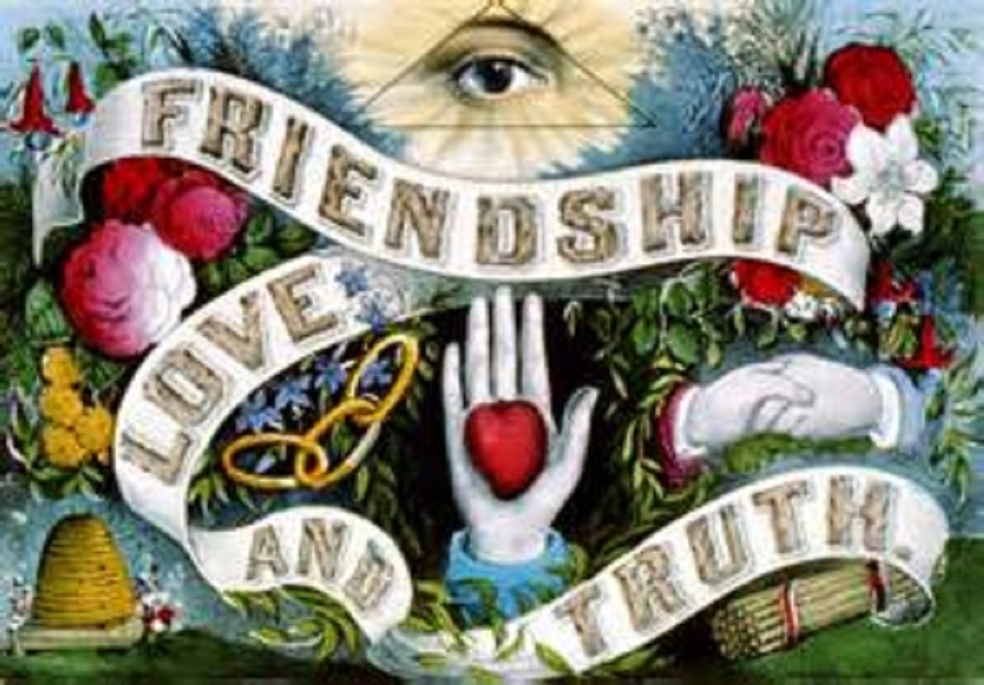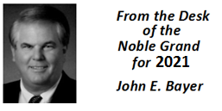
Noble Grand Message
Happy New Year Brother’s & Sister’s of Wildey Lodge
As a new year begins and my term as your Noble Grand ends, I am deeply humbled by all I have learned over these past two years.
I have seen long time members move to a higher calling and new members come into the lodge to fill the void they have left. This ebb and flow of membership is inspiring to be part of. For it teaches what true Friendship, Love and Truth is all about.

It has been an honor for me to be your Noble Grand during these trying times. For all of you have showed an enduring spirit of what Odd Fellows is all about.
I will depart all of you with these words of wisdom. Friendship is Inspiring. Love is a Commitment. Truth is a Reward.
Thank you all for allowing me to be the Noble Grand of this Lodge.

January & February Birthdays
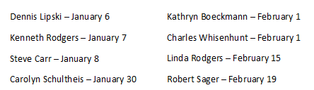

DOG TRAINING
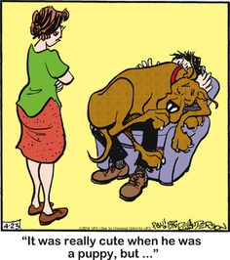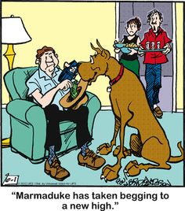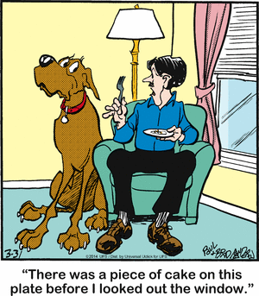

REFRESHMENTS for January & February 2022
January 11 | Restaurant to be announced at meeting
January 25 | Open Installation of Officers  Dinner at 6:00 pm at lodge followed by Installation
February 8 | Restaurant to be announced at meeting
February 22 | Restaurant to be announced at meeting

Dues Reminder
Annual Dues of $40.00 are to be paid by December 31, 2021 to Secretary, Pamela Whisenhunt. If you have not yet paid your dues please mail your payment to Secretary, Pamela’s home address.

INSTALLATION OF OFFICERS January 25, 2022
The following members will be installed as the 2022 officers
Noble Grand Carroll Ray White (PG)
Vice Grand Walter Clifton (PG)
Secretary Pamela Whisenhunt (PG)
Treasurer Charles Whisenhunt (PG)
Warden Jeffrey Parrotte
Right Support to NG Francis LaVar (PG)
Left Support to NG Larry Endicott
Conductor Daniel Flynn
Chaplain Dennis Lipski (PG)
Color Bearer Carolyn Schultheis
Inside Guardian Kenneth David
Outside Guardian Robert Sager (PG)
Past Noble Grand John Bayer (PG)
Right Support to VG Kenneth Rogers (PGM)
Left Support to VG Linda Rogers
Right Scene Supporter Thomas Kreyling
Left Scene Supporter Genevieve Kreyling

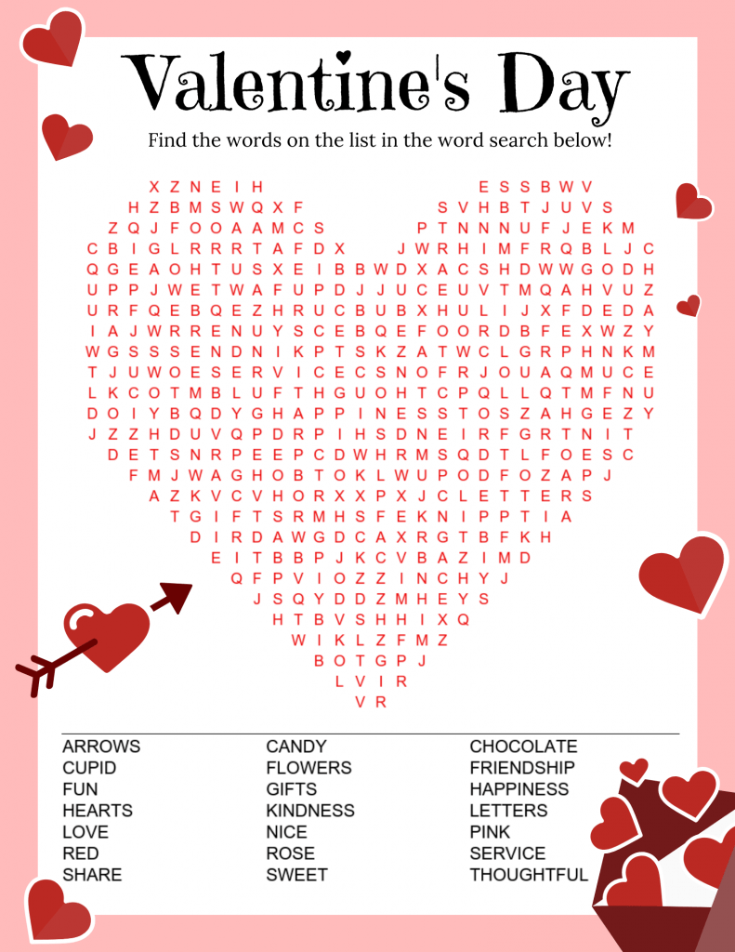

Strawberry Valentine Chex Mix
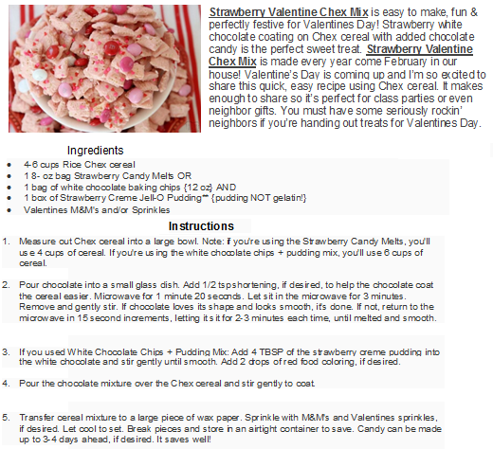
Love Story
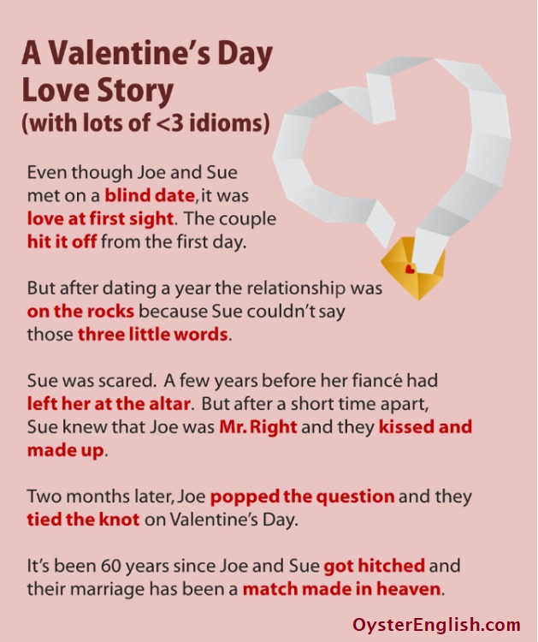

TEST YOUR POSTAL SERVICE KNOWLEDGE
- “Which Article and Section of the Constitution says Congress “shall have Power…To establish Post Offices and post Roads”?
- Article I, Section 3
- Article I, Section 8
- Article III, Section 2
- Article IV, Section 3

- Which Founding Father served as the first Postmaster General?
A. Benjamin Franklin
B. Alexander Hamilton
C. James Madison
D. John Jay

- In what year were postage stamps introduced?
- 1801
- 1836
- C 1847
- 1872

- The Post Office Act of 1792 imposed what penalty for mail theft?
- Prison sentence of up to 10 years
- Public whipping
- 24 hours in stocks in the public square
- Death

- In what year was the Post Office Department replaced with the United States Postal Service?
- 1874
- 1913
- 1950
- 1971

- In 1885, the year domestic postage began being priced per ounce, how much did 1 ounce of mail cost?
- Two cents
- 1 cent
- 5 cents
- 10 cents

- The United States Postal Inspection Service is charged with doing what?
- Enforcing 200 federal laws related to mail service
- Investigating crimes involving the mail service
- Ensuring the safety of high-value deliveries and postal properties
- All of the above

- In 1958, what famous item was sent by registered, first class mail to the Museum of Natural History in Washington?
- Signed, original copy of Declaration of Independence
- Neanderthal skeleton
- Hope Diamond
- Ancient Egyptian mummy

- Who is the current postmaster general?
- Winton Blount
- Louis DeJoy
- Megan Brennan
- Marvin Runyon

- The post office has more retail locations than which of the following national chains?
- McDonalds
- Starbucks
- Walmart
- All of the above
ANSWERS: 1-B, 2-A, 3-C, 4-D, 5-D, 6-A, 7-D, 8-C, 9-B, 10-D St. Louis Post Dispatch

Quote of the Day…!
